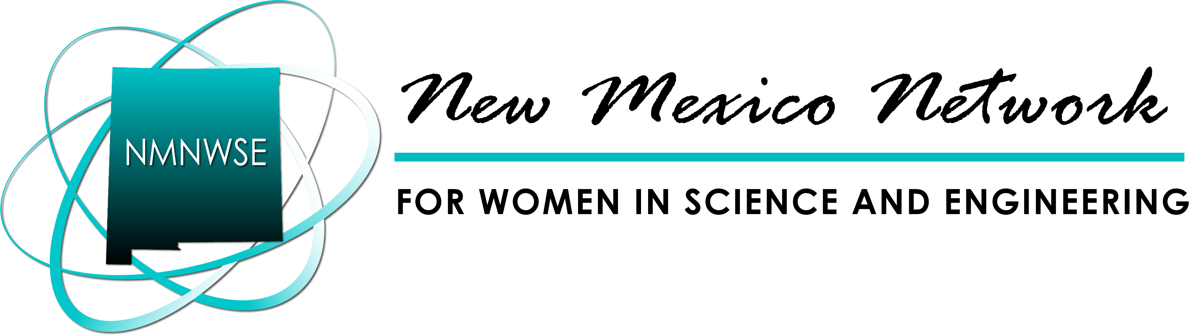

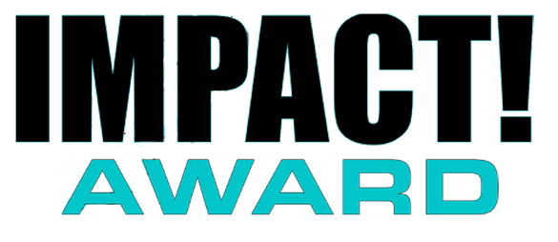

The New Mexico Network for Women in Science and Engineering, in cooperation with the NM Commission on the Status of Women, initiated the NMNWSE IMPACT! Award in 2007 to recognize the contributions of women in New Mexico. This fall, the Annual IMPACT! Award will be presented to a New Mexico woman for her extraordinary efforts in furthering the goals of the Network. These goals include encouraging and helping women enter and succeed in Science, Technology, Engineering and Math (STEM) and related nontraditional careers and promoting networking and communication among women in these careers. The honoree will be recognized during the NMNWSE Annual Meeting and Technical Symposium, which will be held this Fall in Los Lunas, NM.
NOMINEE: ________________________________________________________________________________________
ADDRESS: ________________________________________________________________________________________
CITY: ___________________________________________________ ZIP: _____________________________________
CONTACT PHONE: ________________________________ EMAIL: _________________________________________
NOMINATOR: ______________________________________________________________________________________
AFFILIATION WITH NOMINEE: ______________________________________________________________________
ADDRESS: ________________________________________________________________________________________
CITY: ___________________________________________________ ZIP: _____________________________________
CONTACT PHONE: ________________________________ EMAIL: _________________________________________
PLEASE PROVIDE EMAILS FOR LETTERS OF RECOMMENDATION (In addition to submitting the actual letters):
EMAIL #1: _________________________________________________________________________________________
EMAIL #2: _________________________________________________________________________________________
EMAIL #3: _________________________________________________________________________________________
EMAIL #4: _________________________________________________________________________________________
E-mail your nomination packet to the IMPACT! Award Chair:

nmnwse.impact.award@gmail.com
dsroberson66@gmail.com
or mail a hardcopy to:
IMPACT! Chair, NMNWSE, PO box 51926, Albuquerque, NM 87181
2026 NOMINATION DEADLINE: Friday, September 18th
* Nominations received after the deadline will be considered for next year’s award
Submission Requirements
Application
For your application to be considered complete, please submit the following by the deadline (listed below):
- Nomination Form
- 500-word summary that highlights the nominee’s specific achievements, the impact of her contributions to the goals of the Network, and a brief statement on why she deserves the IMPACT! Award.
- Supporting Material (maximum six pages total):
  - Letters of Recommendation (two minimum, four maximum)
    - Please provide the email addresses of up to four individuals who can write letters of recommendation for the nominee. Letters can come from protégés (mentees), mentors, employers, teachers, leaders, and/or friends.
  - Supporting material should emphasize the nominee’s
    - Mentoring (outreach within the career / job arena)
    - Community Involvement (outreach outside of career / job arena)
    - Outreach to Under-Represented Girls
  - Biographical data that highlights the nominee’s leadership roles, community roles, commitments, mentorship, volunteer work, compensated advocacy work, and media articles that include quantifiable results that support the goals of the Network may also be included.
- One photograph of the nominee to be used for publicity (3” x 4” or 4” x 6”, color or black and white, preferable electronically)
- Nomination Fee of $25 payable to NMNWSE. PO Box 51926, Albuquerque, NM 87181. Please request a receipt for your records.

Eligibility Requirements
Nominees must be:
- over 21 years of age and
- currently living in New Mexico
Previous award recipients are ineligible for consideration. NMNWSE Board members are only eligible after six months from their final date of service. Please email the IMPACT! Chair or call the NMNWSE Communications Chair to verify Award recipients.

Formatting Requirements
- All electronic documents should be saved as a word document or a pdf file using the nominee’s last name and first initial: LastName_FirstInitial.pdf
- All hard copy documents should be submitted on 8.5” x 11” paper, using 12-point font. Larger documents should be reduced.

2026 NOMINATION DEADLINE: Friday, September 18th
* Nominations received after the deadline will be considered for next year’s award
Guidelines for a successful nomination:

IMPACT! Award judges use the following weighting system as a guide for assessing and ranking the quality of the nominees. Candidates are judged on the merits indicated in the submitted nomination packet as NMNWSE does not have the resources to solicit additional supporting materials. Please ensure your packet is as strong as your nominee's IMPACT! If you have any questions regarding the nomination or judging process, contact the NMNWSE IMPACT! Award Chair or the NMNWSE Board. Thank you for taking the time to nominate one of the many outstanding New Mexico women whose IMPACT! deserves recognition.

IMPACT! Award Judging Sheet
Judge:
Nominee Name: | Total Score (out of 130):
 |  | Score
1) Mentoring (outreach within the career / job arena) | (40 Pts Max)
Consider quality of mentoring AND quantity (length of time)
10 additional points awarded for mentoring above and beyond job requirements

2) Community Involvement (outreach outside of career/job arena) | (30 Pts Max)
Consider quality of community outreach AND quantity (length of time)
3) Outreach to Under-Represented Girls | (30 Pts Max)
Consider quality of community outreach AND quantity (length of time)
4) Letters of recommendation | (30 Pts Max)
Note: At least three letters are highly recommended. Letters from a protégé (person mentored) are weighted highest, followed by letters from employers, teachers, and leaders. Letters from others not in these categories, such as a friend, are weighted lowest.
Judges’ notes:
Questions? Contact the NMNWSE Board of Directors
(NMNWSE_Board-L@list.unm.edu)
.

The New Mexico Network for Women in Science and Engineering began in 1975 with a core group of faculty and staff from UNM wanting to reach out to women in science as a group. Incorporated in 1979, the Network works to encourage and help women enter and succeed in Science, Technology, Engineering and Math (STEM) careers and promote networking and communication among members by providing regularly scheduled meetings, talks and other local activities. About 1000 teens each year attend our technical career workshops. Our Annual Meeting and Technical Symposium provides members an opportunity to present technical papers in a supportive environment as well as professional development and networking opportunities.

